Making a new booking
To make a new booking visit http://hospitality.tees.ac.uk/hospitality. The home page shows your upcoming bookings and any bookings you are yet to submit. To start a new booking click on the ‘Create New Booking’ link.
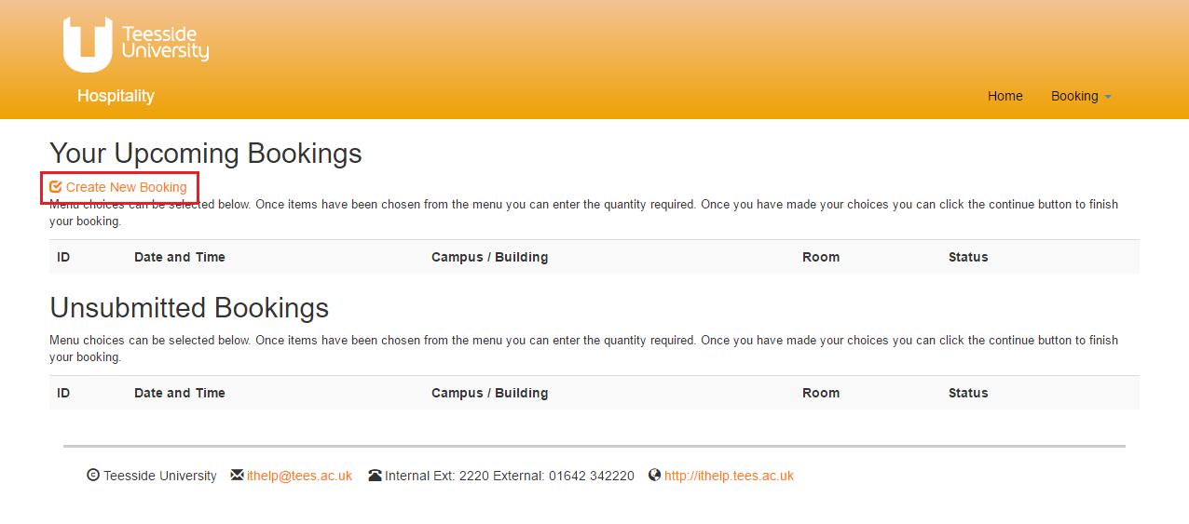
This will open the booking page which allows you to specify the basic details about the booking including the date, time and location.
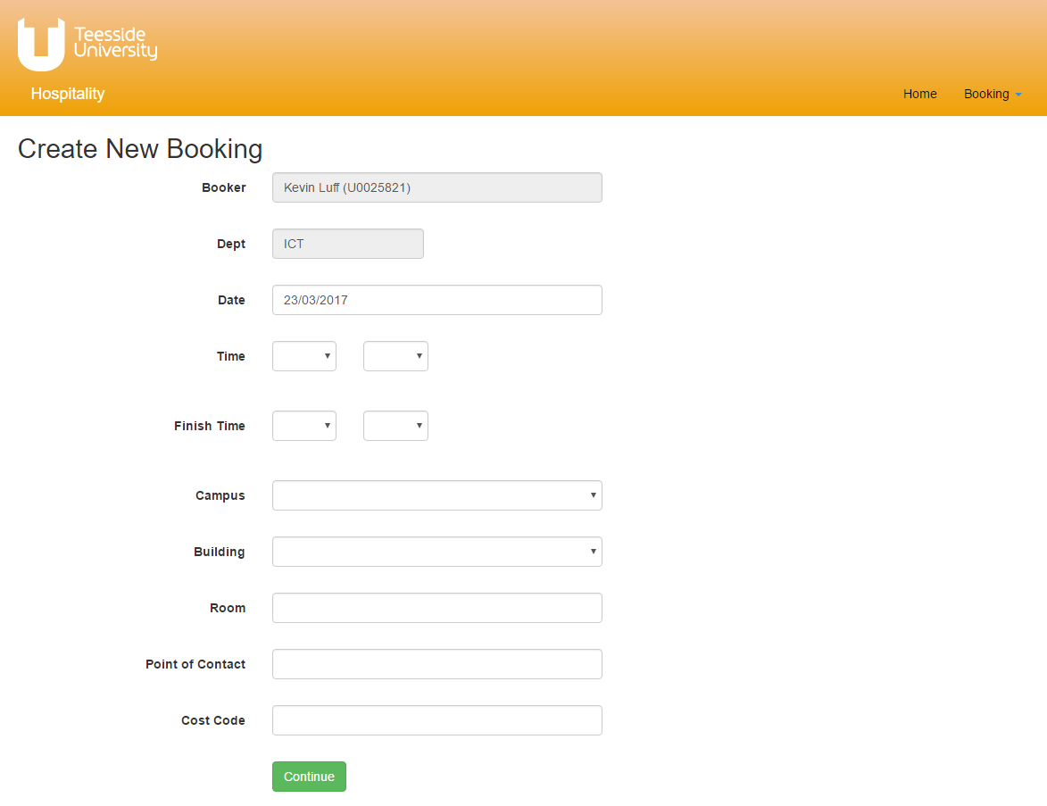
First select the required date by clicking on the date field. This will bring up a calendar allowing you to select the date.  Note: bookings must be made at least three days in advance. If you require a booking before this then you should contact us directly to discuss your requirements. | 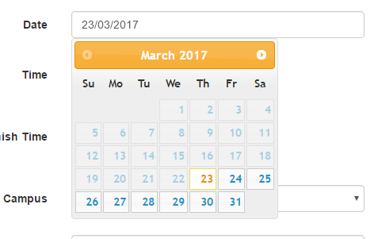
Next select the start and finish times using the drop down menus. | 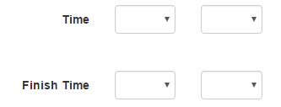
Next select the campus and building where the hospitality is required, and the room or location, using the drop down menus. | 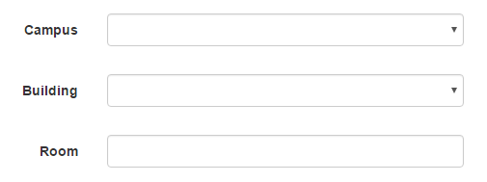
Select the point of contact for the booking by typing in the user’s surname. This will bring up a list of possible choices. Alternatively, you can enter the user’s ID number. Once you find the person, click the name that has appeared to select them.  The point of contact can be a different person to the one who is making the booking. | 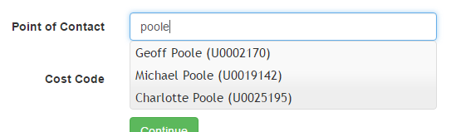
Finally enter in the cost code for the booking. | 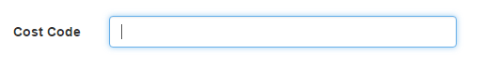
After you have completed the details click the continue button at the bottom of the screen. | 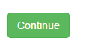

The next page will be the menu. Here you can select which items you want.
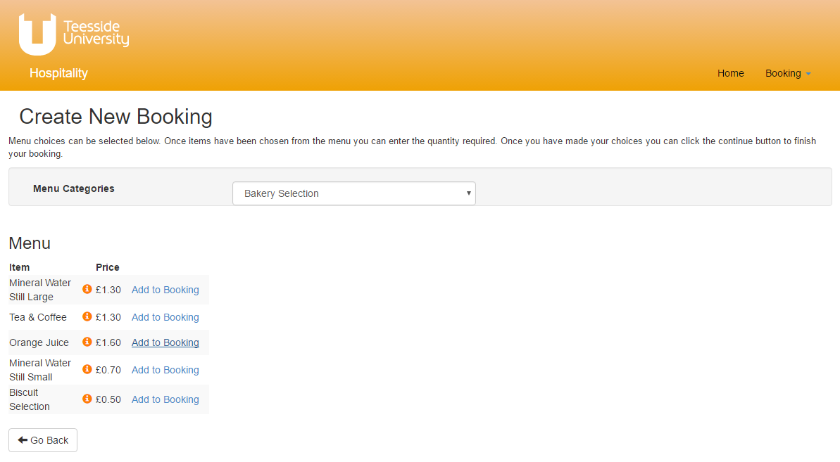
Menu items are displayed on the left side of the screen. Click on the ‘Add to Booking’ link to select the item. To change the items shown on the page use the ‘Menu Categories’ drop down menu to select a different category.
When items are selected they will be displayed on the right side of the screen (see the picture below) in the ‘Chosen Items’ section. The quantity required can be changed using the textbox. The item can also be removed as well.
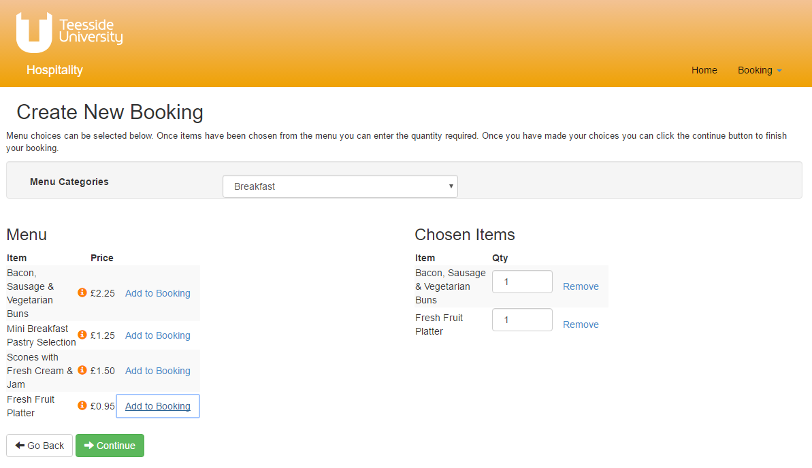
Once all the items required have been selected click the ‘Continue’ button to move to the next stage.

This screen will allow you to specify any additional details about your booking. It will also show the order summary and total cost. If you need to make any changes to your booking you can click on the ‘Go Back’ button at the bottom of the page.
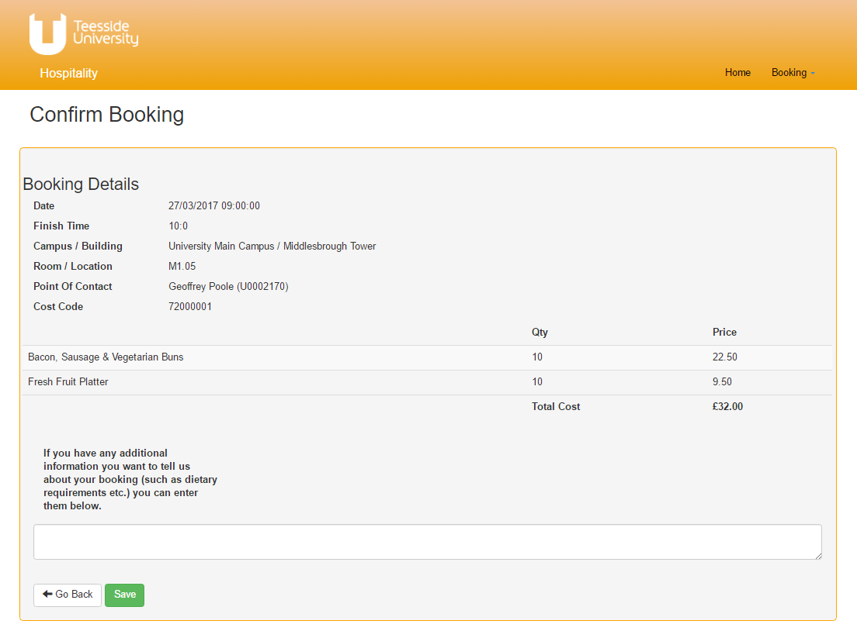
Click on the ‘Save’ button to move to the final stage.

Submitting your booking to hospitality
Please note: your booking has not yet been submitted at this stage. You must click on the ‘Submit Button’ to send the booking to the hospitality team
Your booking will now be saved. You can return to this booking later if you wish. You can also make any changes required by clicking on the ‘Edit Booking Details’ link or the ‘Edit Items’ link. If you are happy with your booking and wish to submit it to the hospitality team click on the ‘Submit Booking’ button at the bottom of the page.
